|  |  |  |  |
| --- | --- | --- | --- |
| **Date:** | **25/05/2020** | **Name:** | **Rachana C Hulikatti** |
| **Course:** | **Digital signal processing** | **USN:** | **4AL17EC108** |
| **Topic:** | **Introduction to Fourier Series & Fourier Transform** | **Semester & Section:** | **6th sem B sec** |
| **Github:** |  |  |  |

**Image of session**

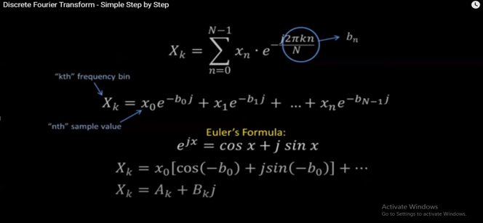

**Report**

**Introduction to Fourier Series & Fourier Transform**

Fast forward two hundred years, and the fast Fourier transform has become the cornerstone of computational mathematics, enabling real-time image and audio compression, global communication networks,

Modern devices and hardware, numerical physics and engineering at scale, and advanced data analysis.

Simply put, the fast Fourier transform has had a more significant and profound role in shaping the modern world than any other algorithm to date. With increasingly complex problems, data sets, and computational geometries, simple Fourier sine and cosine bases have given way to tailored bases, such as the data-driven SVD.

In fact, the SVD basis can be used as a direct analogue of the Fourier basis for solving PDEs with complex geometries. In addition, related functions, called wavelets, have been developed

**Fourier series**

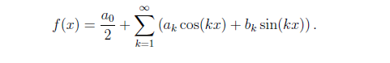

Fourier series approximation to a hat function

% Define domain

dx = 0.001;

L = pi;

x = (-1+dx:dx:1)*L;

n = length(x); n quart = floor(n/4);

% Define hat function

f = 0*x;

f(nquart:2*nquart) = 4*(1:nquart+1)/n;

f(2*nquart+1:3*nquart) = 1-4*(0:nquart-1)/n;

plot(x,f,’-k’,’LineWidth’,1.5), hold on

% Compute Fourier series

CC = jet(20);

A0 = sum(f.*ones(size(x)))*dx;

fFS = A0/2;

for k=1:20

A(k) = sum(f.*cos(pi*k*x/L))*dx; % Inner product

B(k) = sum(f.*sin(pi*k*x/L))*dx;

fFS = fFS + A(k)*cos(k*pi*x/L) + B(k)*sin(k*pi*x/L);

plot(x,fFS,’-’,’Color’,CC(k,:),’LineWidth’,1.2)

end

**Fourier series for a discontinuous hat function**

dx = 0.01; L = 10;

x = 0:dx:L;

n = length(x); nquart = floor(n/4);

f = zeros(size(x));

f(nquart:3*nquart) = 1;

A0 = sum(f.*ones(size(x)))*dx*2/L;

fFS = A0/2;

for k=1:100

Ak = sum(f.*cos(2*pi*k*x/L))*dx*2/L;

Bk = sum(f.*sin(2*pi*k*x/L))*dx*2/L;

fFS = fFS + Ak*cos(2*k*pi*x/L) + Bk*sin(2*k*pi*x/L);

end

plot(x,f,’k’,’LineWidth’,2), hold on

plot(x,fFS,’r-’,’LineWidth’,1.2)